**Project Design Phase-I**

**Solution Architecture**

|  |  |
| --- | --- |
| Date | 15 October 2022 |
| Team ID | PNT2022TMID10517 |
| Project Name | University Admit Eligibility Predictor |
| Maximum Marks | 4 Marks |

**Solution Architecture:**

Solution architecture is a complex process – with many sub-processes – that bridges the gap between business problems and technology solutions. Its goals are to:

* Machine learning algorithms to be used depending on the data we are going to process such as images, sound, text, and numerical values. The algorithms that we can choose according to the objective that you might have it may be Classification algorithms are Regression algorithms. As it is a kind of classification problem you can apply any of the  following Algorithms
  + - 1. Logistic Regression
    - 2.Decision Tree Classifier
    - 3.Random Forest Classifier
    - 4. KNN

**Logistic Regression:**

Logistic Regression is used when the dependent variable (target) is categorical. For example,

* To predict whether an email is spam (1) or (0)
* Whether the tumor is malignant (1) or not (0)
* Out of all the algorithms Logistic Regresson got the highest accuracy
* There are many numbers of model evaluation techniques for the classification type of machine learning models. the following are widely used as **Accuracy_score**, **Confusion matrix,** and **Roc- Auc Curve.**

Next, we will be building a web application that is integrated to the model we built. A UI is provided for the uses where he has to enter the values for predictions. The enter values are given to the saved model and prediction is showcased on the UI.

This section has the following tasks

* **Building HTML Pages**
* **Building server-side scrip**t

Next, we will integrate the flask and IBM cloud for deployment. Then finally flask is integrated with the scoring endpoint.

**Solution Architecture Diagram:**

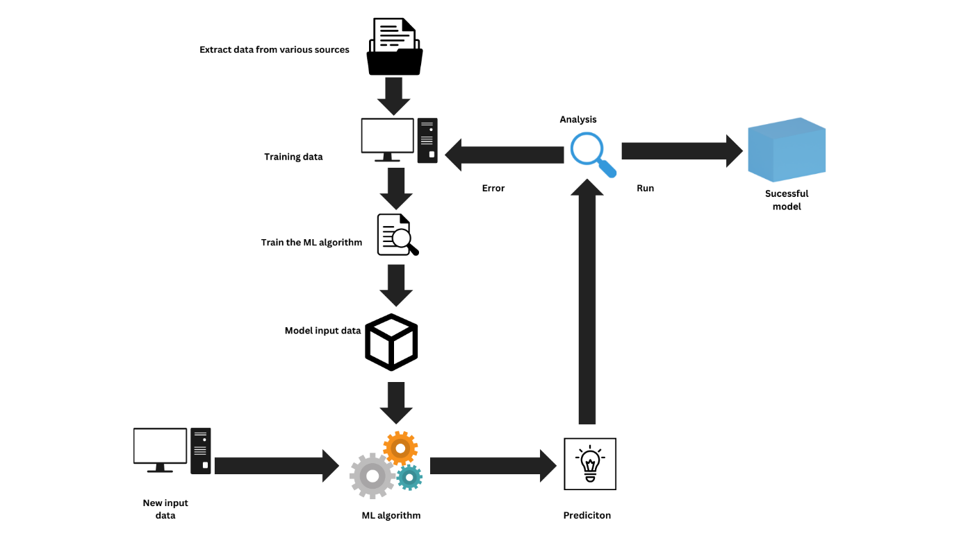

Figure 1: Architecture and data flow of the University Admit Eligibility Predictor

**Reference: https://medium.com/@jigar18011999/university-predictor-by-machine-learning-2d880e9f3a3**